The Staci Stephens Fund, Inc.
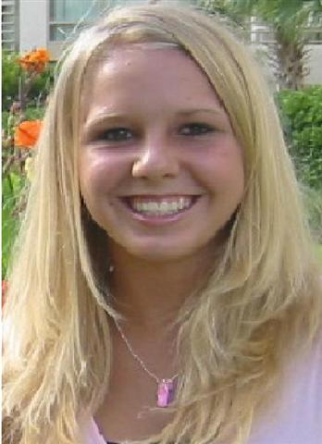
Staci Stephens was a Christian student at Timber Creek High School. On March 13, 2005, she died unexpectedly from a virus (Viral Myocarditis) that enlarged her heart. She lived the Christian life and practiced her Christianity in so many ways. To honor her memory, her parents, Barry and Kristen Stephens, have established the Staci Stephens Fund, Inc.

Staci had a big heart. Ever since becoming a Christian at the Student Venture FastBreak conference in January of 2004, Staci developed a big heart for God and a big heart for people. She said, “Everything I do is for the glory of God and I finally know the life that I’ve been missing.” Staci had asked God for a her own ministry, not a copy of anyone else’s, on campus. She overflowed with the love of Christ toward everyone she met. When she died, everyone on campus had the opportunity to hear about a saving relationship with Jesus, just as Staci had desired. Additionally, in January of 2005, she was rebaptized at the Fastbreak conference held in Cocoa Beach. These conferences had a huge impact on Staci’s life and death. If it weren’t for Student Venture conferences, Staci’s destiny would not be so clear. God chose a different path for Staci, one that didn’t include marriage and kids but instead, included bringing people all over the world to know Jesus Christ.

Staci lived life to the fullest in her 16 years. She gave her all in cheerleading, Student Venture, ministry at Church, school, and many other activities. Her life, her actions, her relationships, and her words all reflected the glory of God.

This grant is given with the prayer that those who receive it will walk closely with Jesus, make an impact on their campus, and live life to the glory of God.

Guidelines
1. Each student wanting to be considered for a scholarship must complete this form, showing creativity, thought, completeness, and neatness to Mrs. Stephens.
2. A student’s commitment will determine the amount. Non-Christians wanting to know God, new Christians wanting to grow, and Christians wanting to make an impact will be given top priority.
3. A recipient may contribute back to the fund in order to replenish what has been given and make future monies available to others. For instance, a student could donate time through helping with the Staci Stephens website or help with a garage sale that donates the money back to the fund.
4. The student may also contribute some of his/her own money towards the cost of the event if they cannot assist with the Staci Stephens Fund, Inc. This money may come from allowances, gifts from parents or relatives, a job, and/or money raised through other work projects.
5. Money is nontransferable. If a student does not attend the event, the money may not be transferred to another student.

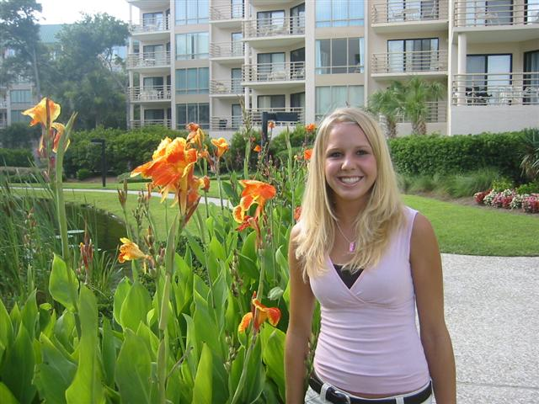
The Staci Stephens Fund, Inc.
Directions: Please fill this out creatively, neatly, thoughtfully, and completely on another sheet of paper.
Students Name:
Today’s Date:
High School:
Current Grade:
Phone Number (home and Cell):
Email Address:
AIM ID:
Event you would like to attend:
Attached list showing 10 hours of community service hours

Creatively, on a separate page, provide your response to the following questions:
- a) Did you personally know Staci? If so, what was your relationship with her? If not, have you been to the website, read her testimony, or seen the video? B) How did you hear about Staci’s story if you did not know her? C) Describe how Staci’s Story has impacted your life. (answer only the questions that are relevant to you)

- Why do you want to attend this event?
- Answer one of the following questions: a) How did you receive Christ as your personal Savior? b) Did Staci’s story cause you to re evaluate your relationship with Christ and How? c) If you are not yet a believer in Christ, where are you at on your spiritual journey and has Staci’s story caused you to rethink your beliefs?

- a) What has been your involvement with Student Venture or other Christian related events? b) If you have not been exposed to Student Venture, how has Staci’s story caused you to want to be more involved with Student Venture or other Christian related events?

- How have you grown in your faith since Staci’s death, or viewing Staci’s story, or being involved with Student Venture, or other Christian Related Events?

- a) Describe the ministry you would like to have on your campus or ministry you currently have. b) Has knowing Staci or viewing Staci’s story made you want to expand your ministry? If so, how? c) If you currently don’t have a ministry on your campus, whom do you want to reach out to and why?

- Are you able to contribute toward the event cost? If so, please indicate the amount you would like to receive.

